Day 1:-
1 Diagram for desktop PC and all other parts of Motherboard, CPU, RAM, GPU and Both HDD and SSD

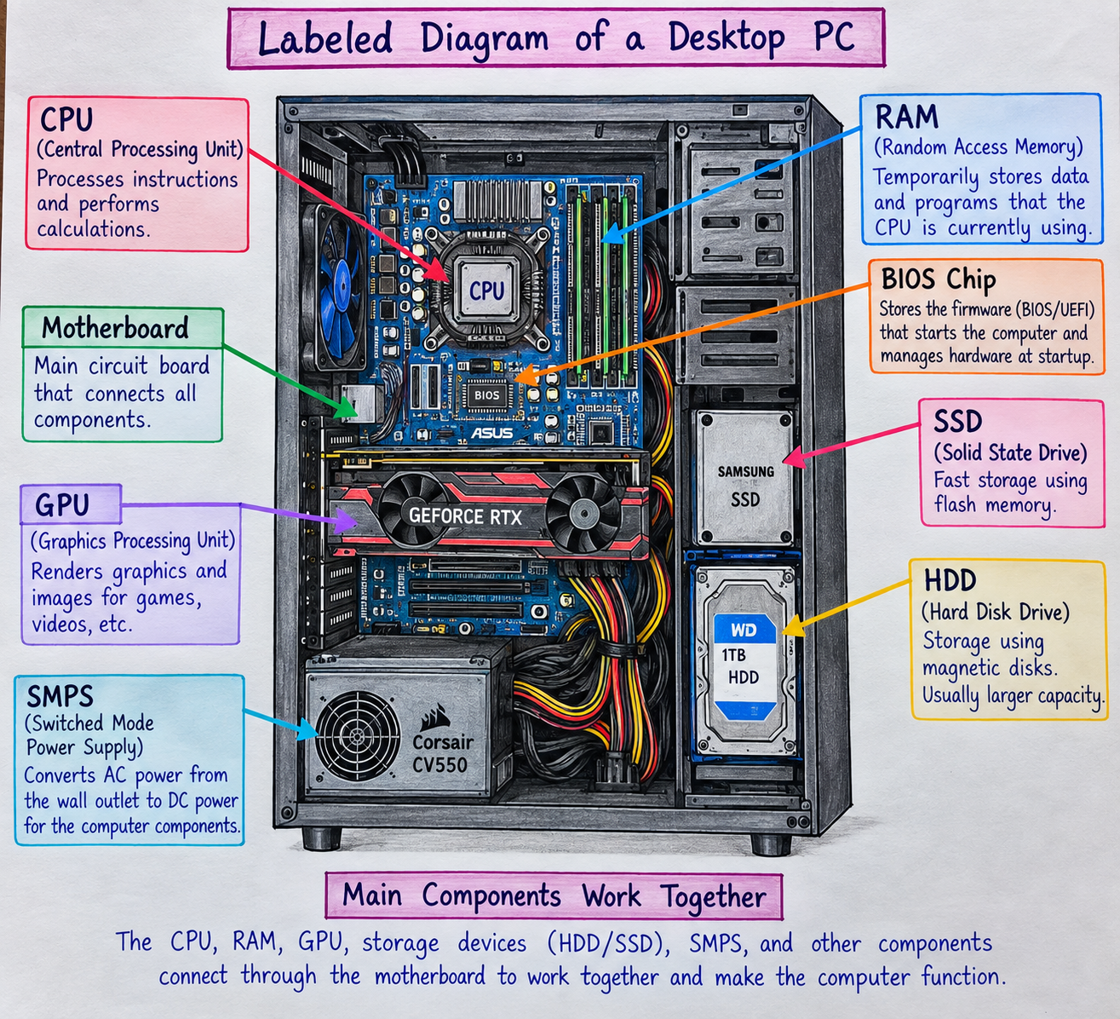

2:-Difference between HDD ( harddisk) and SSD( Soild State Drive)
Feature | HDD | SSD
1. Speed | Generally slower because it uses mechanical parts. | Generally faster because it uses flash memory.
2. Moving Parts | Has spinning platters and a moving read/write head. | Has no moving mechanical parts.
3. Durability | More vulnerable to damage from physical shocks or drops. | More resistant to physical shocks because it has no moving parts.
4. Noise | Can produce noise while the disk and read/write head are operating. | Silent during normal operation.
5. Cost & Capacity | Usually cheaper per GB and commonly available in large capacities. | Usually more expensive per GB, especially at higher capacities.
6. Typical Use | Often used for bulk storage, backups, and large files. | Commonly used for operating systems, applications, laptops, and gaming PCs.

3:- Role of CPU, RAM and GPU in PUBG/Free Fire
CPU — Central Processing Unit
The CPU processes the instructions and calculations required by the game. It handles tasks such as game logic, player movements, physics, and communication between different components.
RAM — Random Access Memory
RAM temporarily stores the game data and other information that the CPU needs while the game is running. Sufficient RAM allows the game and background applications to access data quickly and helps reduce slowdowns caused by insufficient memory.
GPU — Graphics Processing Unit
The GPU processes and renders the game's visual content, such as characters, environments, textures, lighting, and effects. A capable GPU helps provide smoother gameplay and allows the game to run at higher graphical settings.

4:- Hardware Upgrades for the Latest FIFA
would consider upgrading components depending on the existing specifications.
1. GPU
I would consider upgrading the GPU because it is responsible for rendering the game's graphics, textures, lighting, and visual effects. A more capable GPU can provide smoother gameplay and support higher graphical settings.
2. CPU
I would consider upgrading the CPU if the existing processor does not meet the game's requirements. A capable CPU helps process game logic, physics, player movements, and other calculations efficiently.
3. RAM
I would consider increasing the RAM if the PC does not have enough memory for the game and other background applications. Sufficient RAM helps the system handle multiple tasks smoothly.
4. SSD
I would consider installing an SSD if the computer currently uses an HDD. An SSD can improve Windows startup and game loading times, although it does not directly provide the same graphics-performance improvement as a GPU upgrade.
5. Cooling System
I would check or upgrade the cooling system if the PC becomes too hot during gaming. Good cooling helps maintain stable component temperatures and performance during long gaming sessions.
6. Power Supply (SMPS)
I would consider upgrading the SMPS (Switched-Mode Power Supply) if the new components require more power than the existing power supply can safely provide. A suitable power supply ensures that the CPU, GPU, storage, and other components receive stable power.

